

Provider Quick Reference for Medication/Ancillary orders

Log in. Access the patient: type your patient’s last name in the name field, then press enter on the keyboard. The Medication Orders under the Orders tab is shown. Add, discontinue, change, reorder, and e-sign medications here.
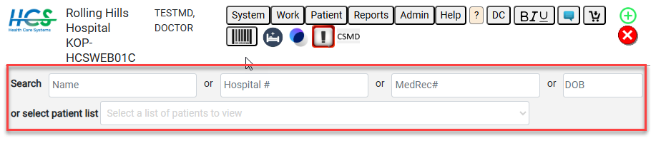

To add a med, select the Add button. A drop-down list with your frequently ordered meds appears in the description column. Select the black text SIG to order it as displayed. Fields can be changed after SIG selection. Select the medication name to complete all fields manually. Dose, Route, Frequency, and Indication are required fields.
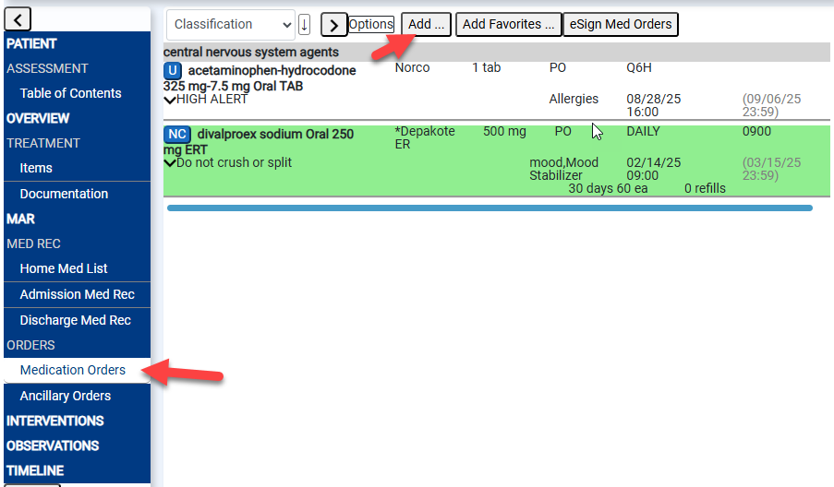

To order something different than your top meds, begin typing the name of the med in the description field.
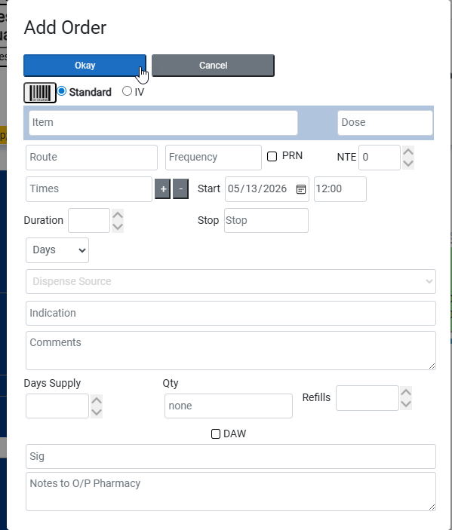
After you have entered all of the information, click Okay at the top of the screen. Since you are in add mode, the system will automatically prompt you to enter another med. If that was your last med to enter, select Cancel.

ADD FAVORITE ORDER SETS
Select Add Favorites (button to right of Add) to add order sets. A window with a list of available sets appears. Select the appropriate favorite. A checkbox in the Active column indicates a medication that will be added with the set. A blank checkbox indicates a medication that will not be added. Make your selections then click Add Checked Orders to Patient to add as displayed, or Add Checked Orders, Edit before Adding to make changes before adding.
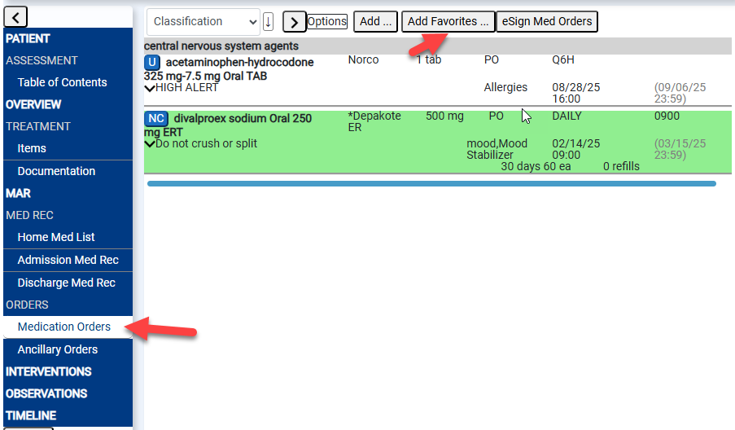

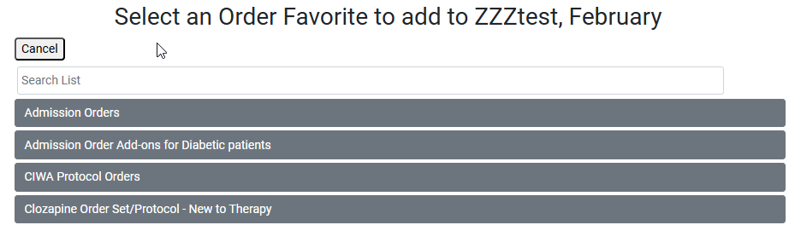

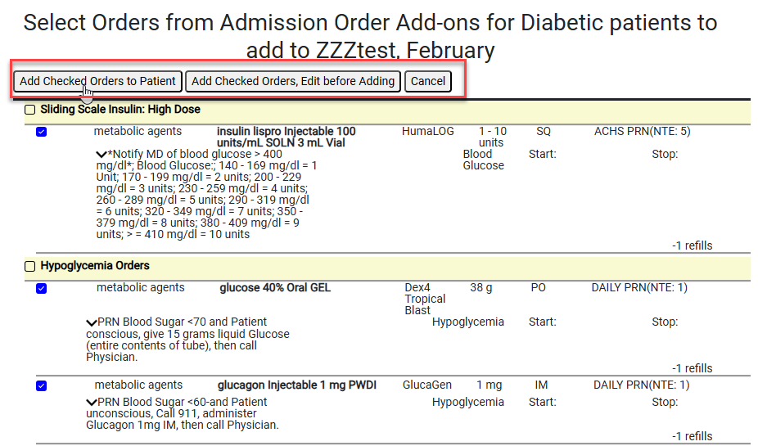

DISCONTINUE OR CHANGE MEDICATION(S)
To discontinue a medication (med), click once on the box located at the top left of the order. Discontinued orders are yellow. To change a current med, double-click the field you want to change. Updates to dose, route, or frequency will cause HCS to ask if you want to discontinue the current order. Select Yes to let the system automatically discontinue the old order and automatically add a new one with your changes. New orders are highlighted in blue until pharmacy verifies them.

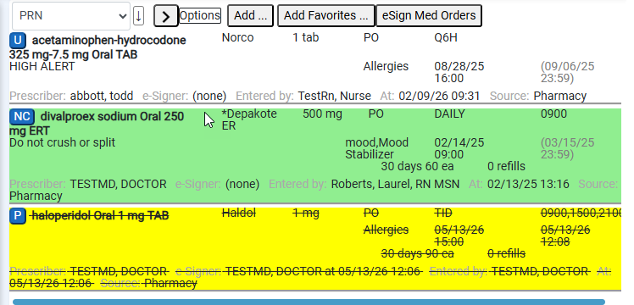

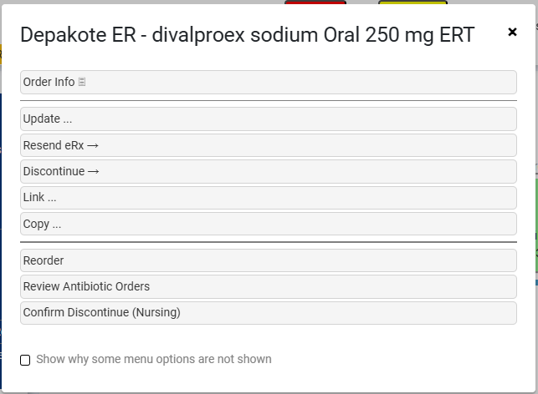

REORDER BEFORE HARD STOP DISCONTINUE
Select Patients with meds to be REORDERED. Select the first patient in the list. Meds needing reorder are grey. Left-click a med and select Reorder from the drop-down list. E-sign, then advance to the next patient.


E-SIGN ORDERS
After entering all orders, click E-sign med orders. Click to sign just the orders you added, or all unsigned orders. Orders unsigned, not written by you are green.

Provider Quick Reference Page 2 of 2

ADD ANCILLARY ORDER(S)
Access the patient, then click the Ancillary Orders tab under the Orders tab.
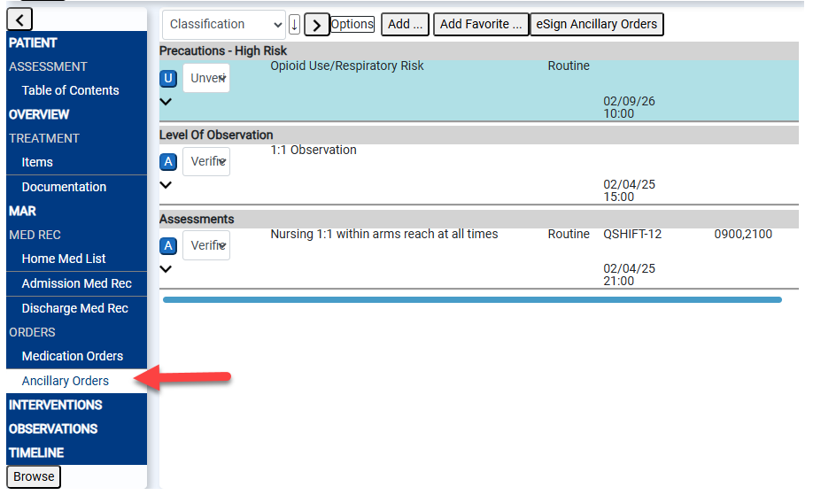
Select the Add button, just like with a med order. If you don’t see the order you want, begin typing the order name in the description field. When it appears in the drop-down, select it. Click Okay. Ancillary Orders do not require e-sign. Ancillary orders can be discontinued (uncheck the active checkbox) and updated (click in the field you want to change) in the same fashion as medication orders. Select Cancel to exit add mode.

COMPLETE DISCHARGE MEDICATION RECONCILIATION AND ORDERS
- For a patient that is about to discharge, click the Discharge tab under the Orders tab.
  - A list of all medications is shown, including those provided in the facility (green) as well as those the patient brought from home (red). If a medication was brought from home and prescribed exactly the same in the facility, there will only be one item to address (blue).
  - Every medication must be either continued or stopped. A prescription can also be generated by checking the Rx box, which displays in black and will automatically select the continue checkbox.
  - Add new orders to be taken at home by selecting the Add button.
- Click to check the appropriate check box in the first left three columns on each medication.
- Select the e-sign button when all medications have been addressed.
